Project: UART Based Calculator

Kuldeep Gohil, Darren Biscocho, Aaron Mai

CECS 262

Professor Hayter

07 December 2018

Purpose

The purpose of this project was to learn and understand how to send and receive bits of data between the 8051 board and hyperterminal. Furthermore, the hyperterminal showed a menu where users could interact with the program and simulate many calculator operations. With the knowledge of C language, we were able to bridge the connection between the 8051 board and hyperterminal. The 8051 board was used to process these operations and the results were sent back to the hyperterminal to be displayed.

8051 UART Operational Theory

For this lab, we are using UART, which stands for the Universal Asynchronous Receiver/Transmitter. We will be transmitting and receiving data between the 8051 board and the hyperterminal program on our computers. The receiver and transmitter pins were can be found on pins P3.0 and P3.1 on the 8051 Microcontroller. To use a 9600 baud rate, we had to change the TH1 from 0xFA to 0xFD. We were to make functions such as the getString, getByte, sendString, and sendByte functions that were necessary in receiving and transmitting data. To create the menu based calculator, we used the sendString function to take in a string and send each character one by one using the sendByte function to display the messages of the menu, operands, and results. We created an array called rxBuffer that took in a user input up to 4 characters. When doing basic operations, we required the user to enter a 4 digit decimal and receive the ASCII value of that input and convert it to a short using the logic “or” operation. This was calculated by using “0x30 | n,” with “n” being the number. After converting to a short, it would be used in the chosen basic operation with the result sent back to the console. For our project, we created a decimal to binary and decimal to hex conversion functions using their own algorithms. To get the the binary of a decimal, we constantly divided the decimal by two (decimal/2) and got the remainder(decimal%2) to send to the buffer. After sending it to the buffer, we sent it one at a time backwards to display the binary value. This was the same with the hex function, except dividing by 16.

Schematic

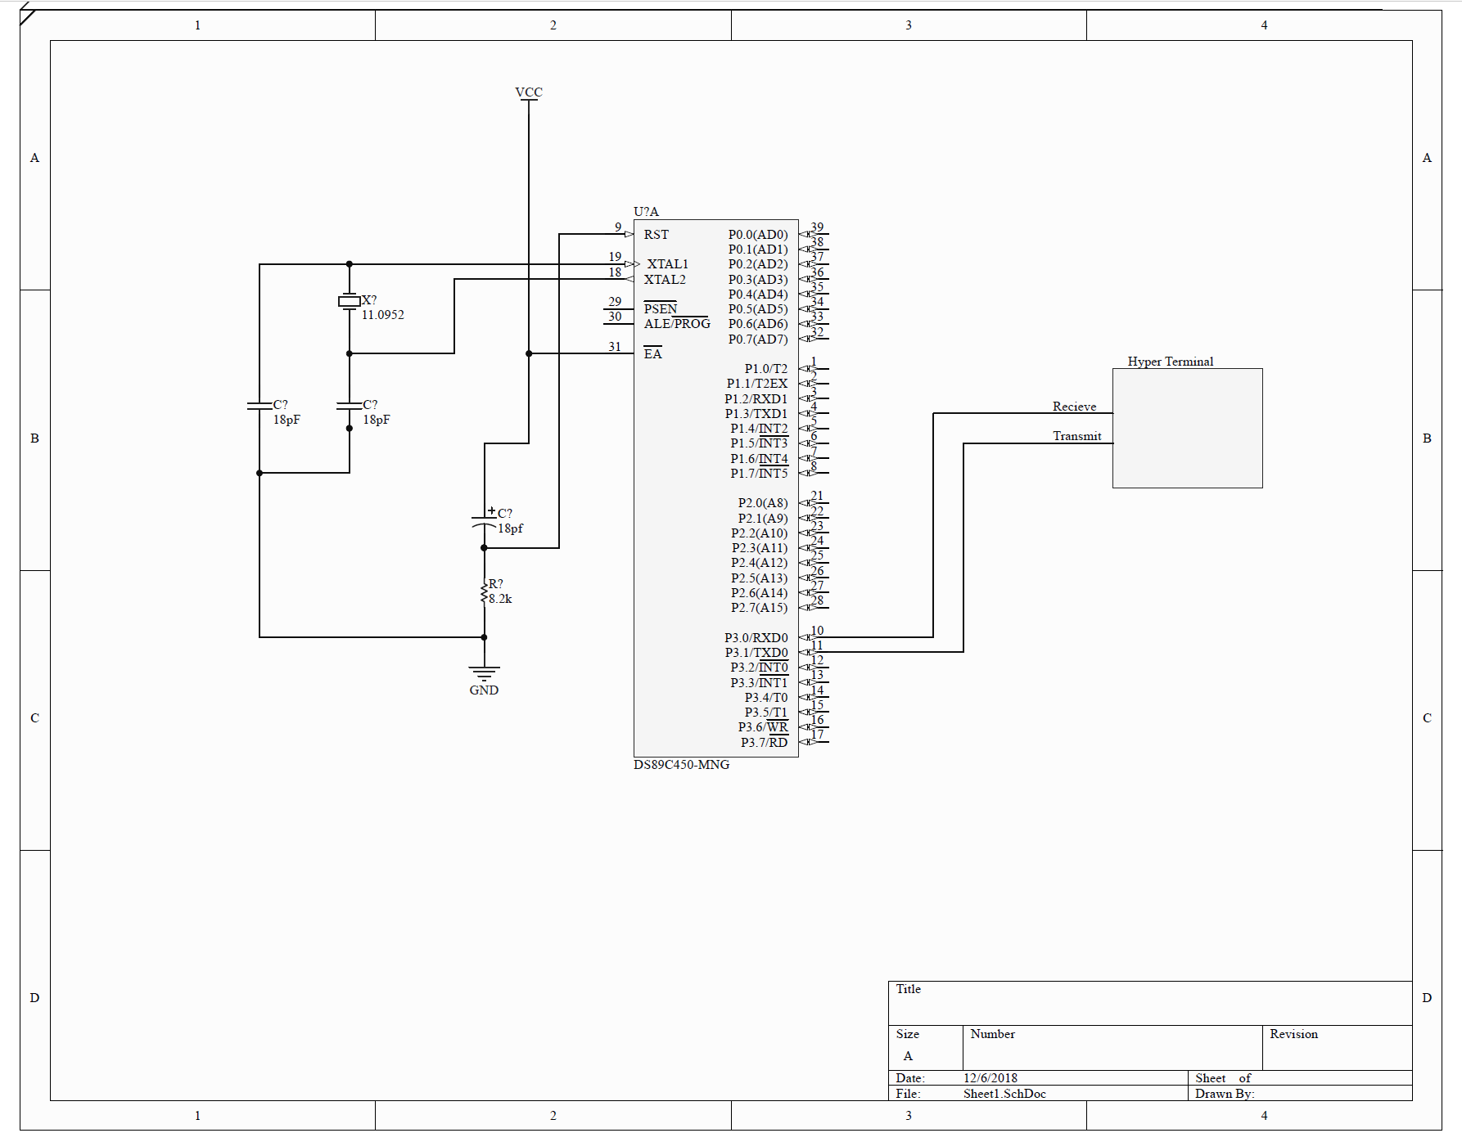

Flowcharts

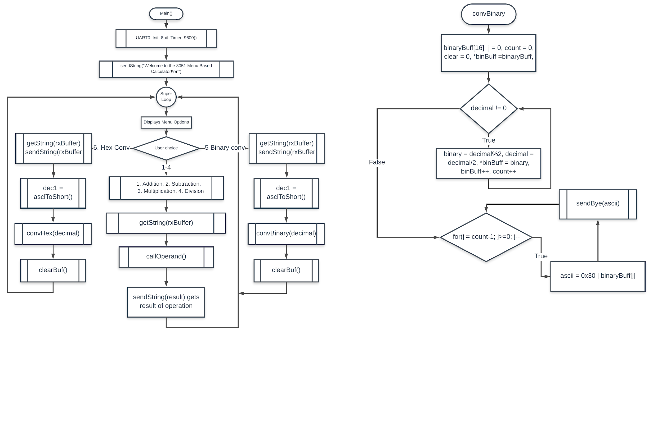

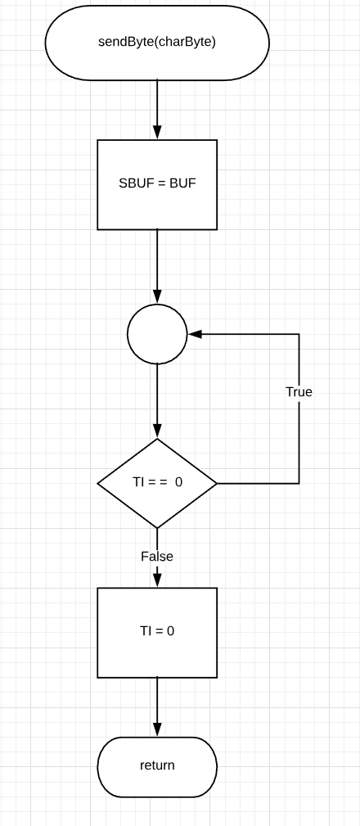

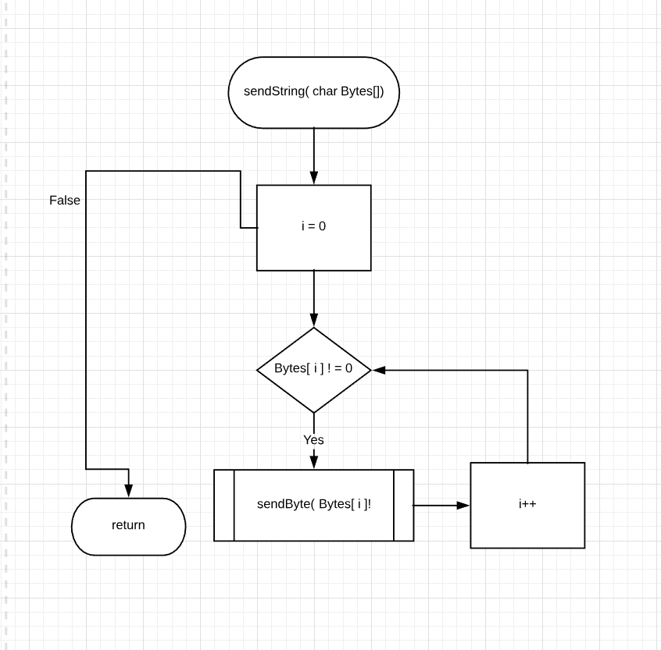

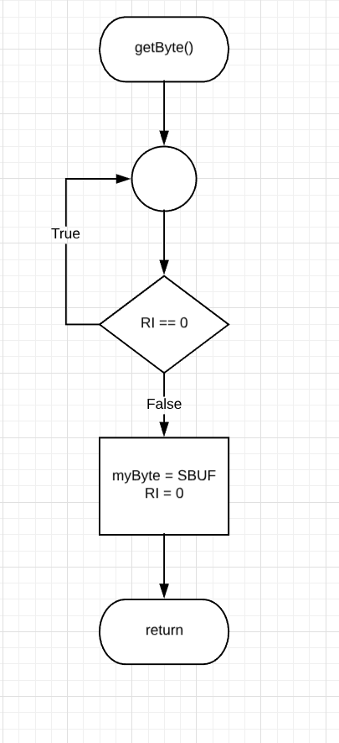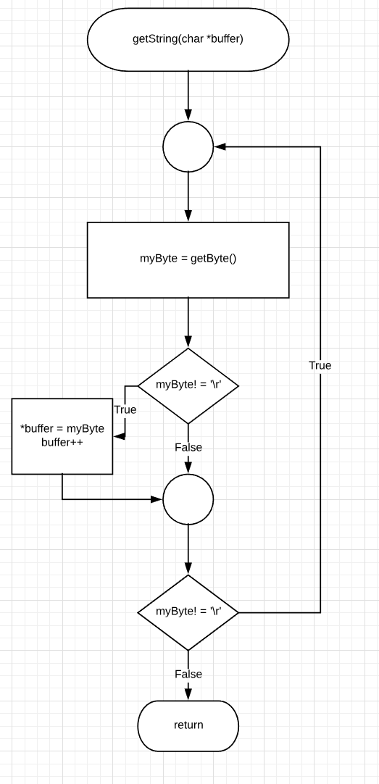

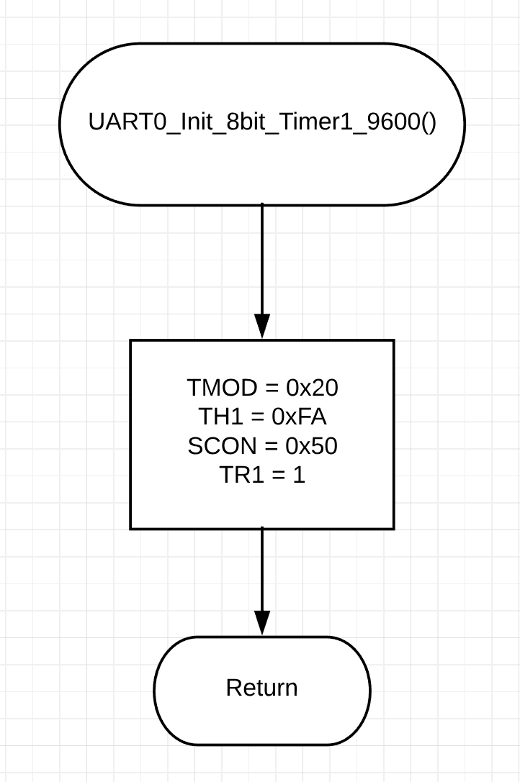

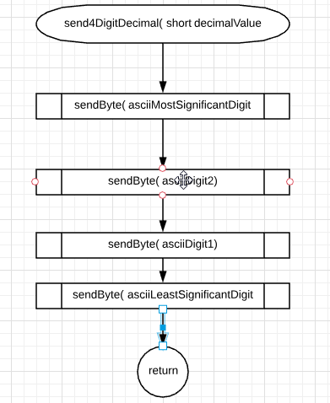

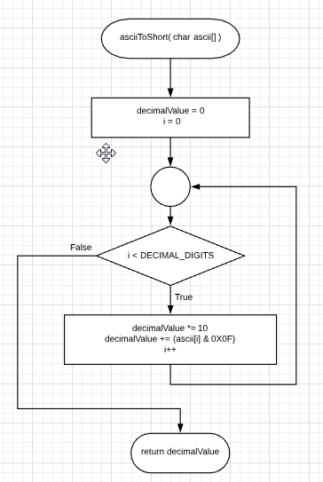

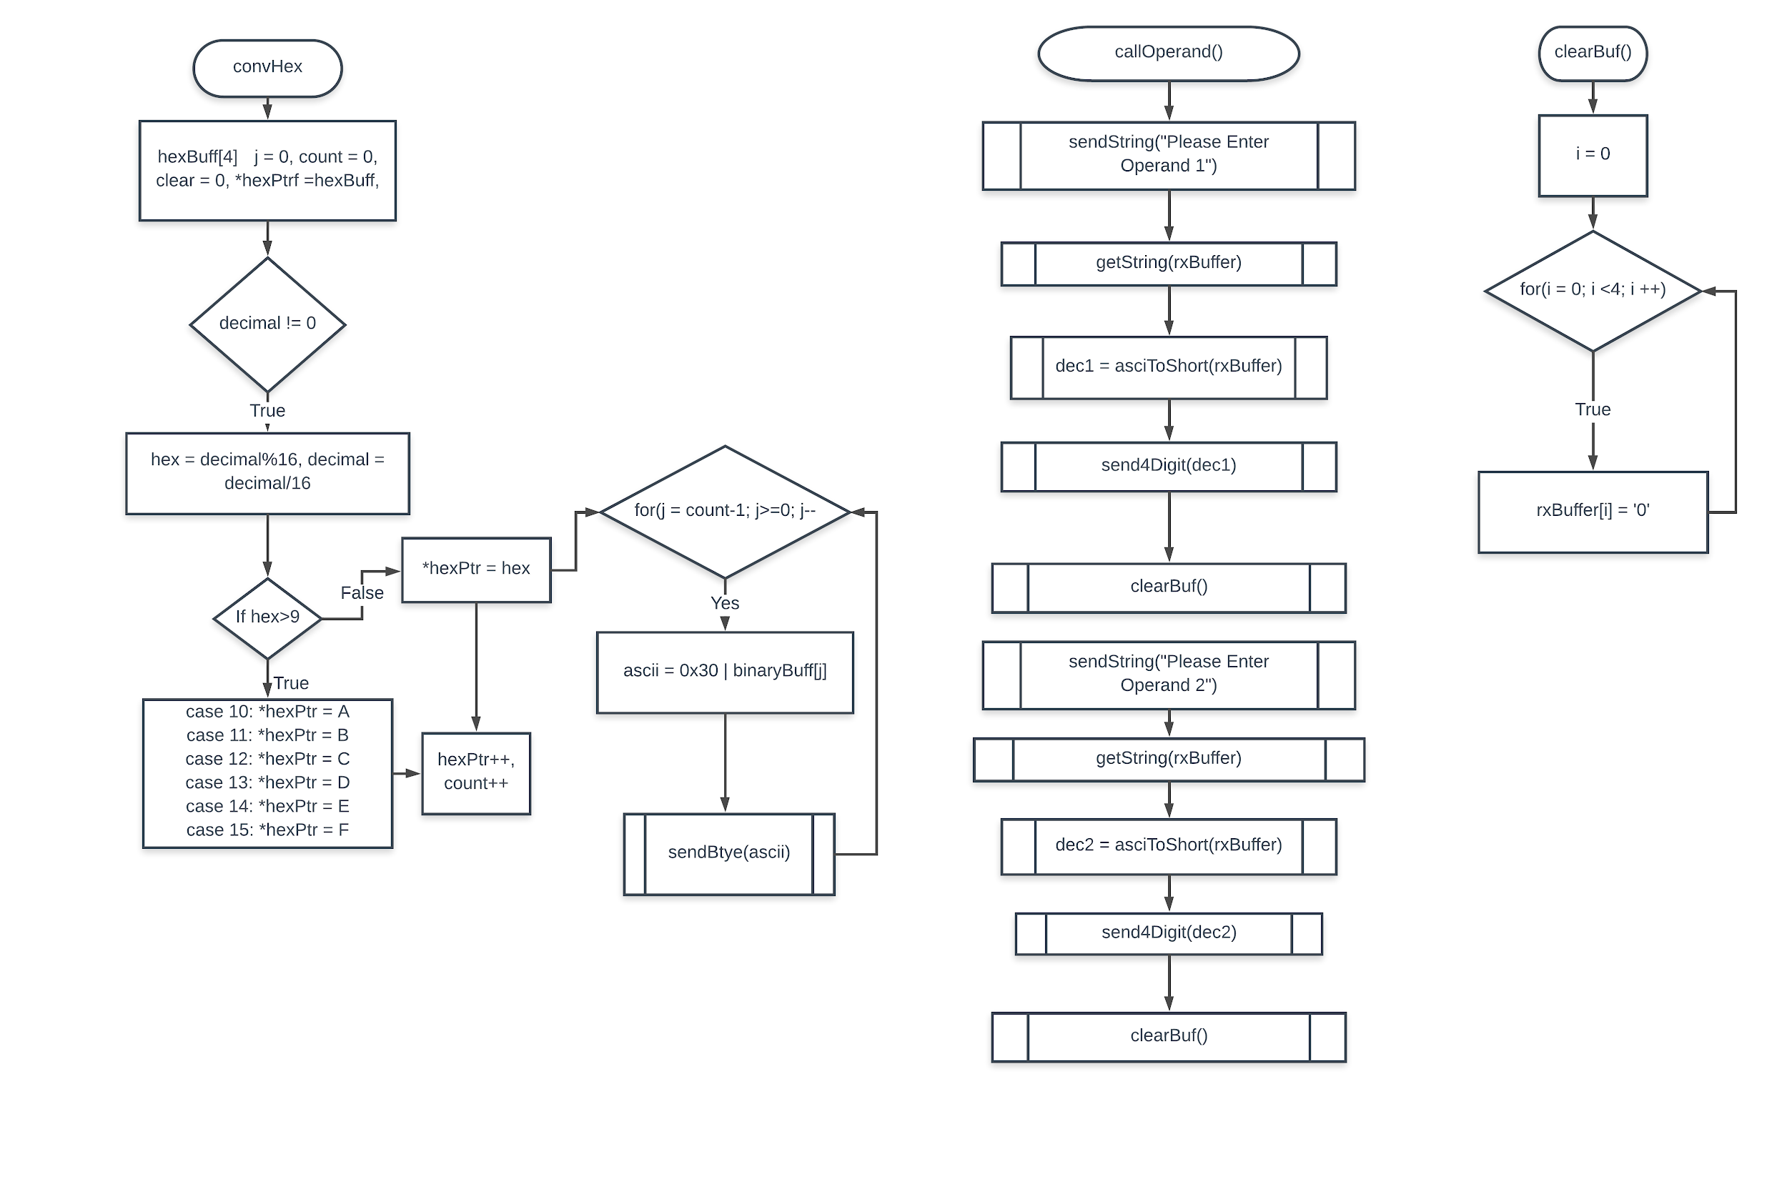





C Source Code Screenshots

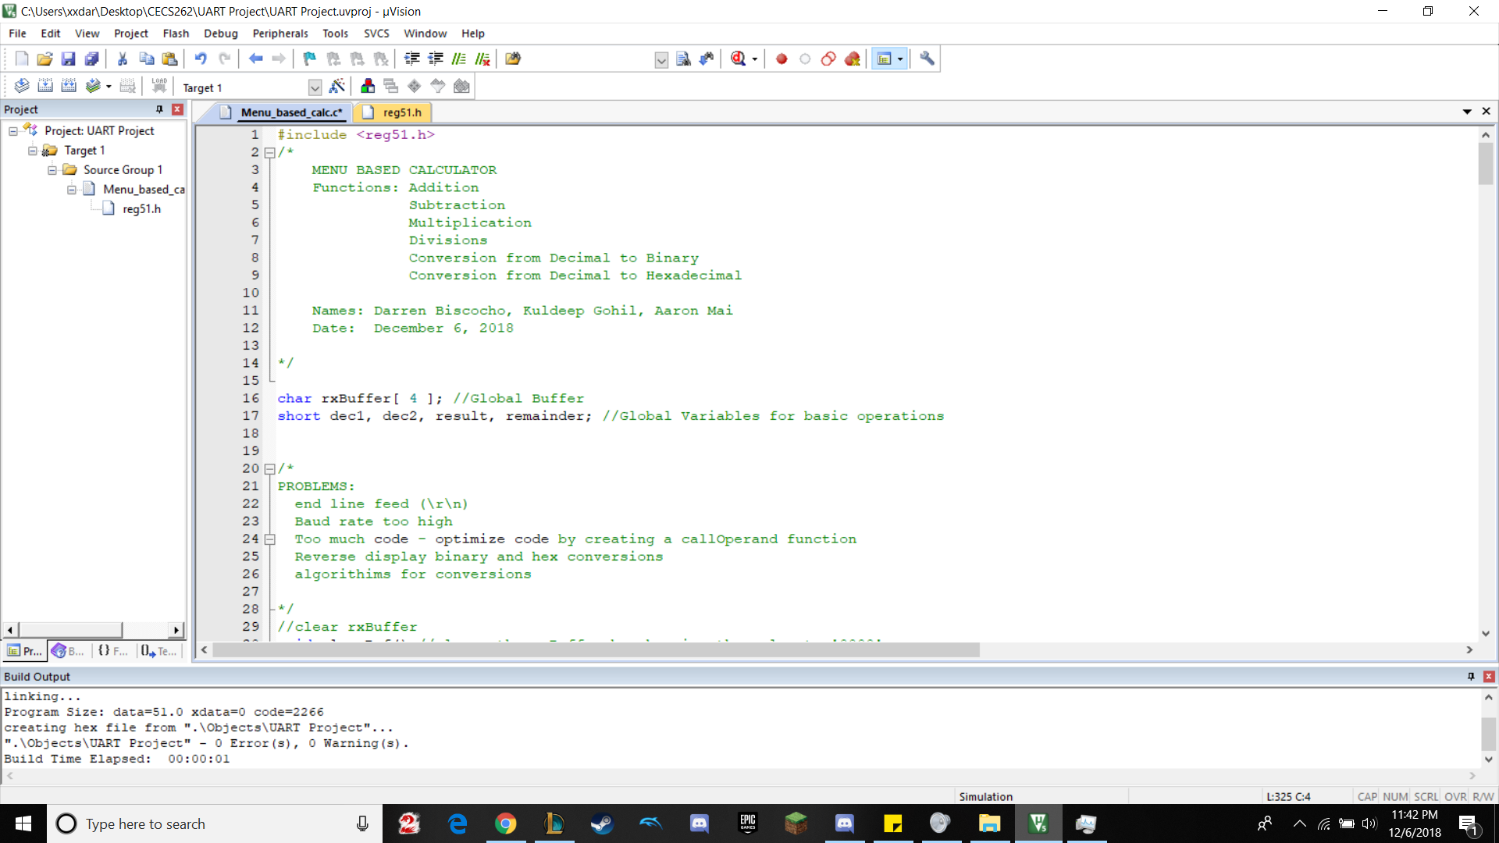

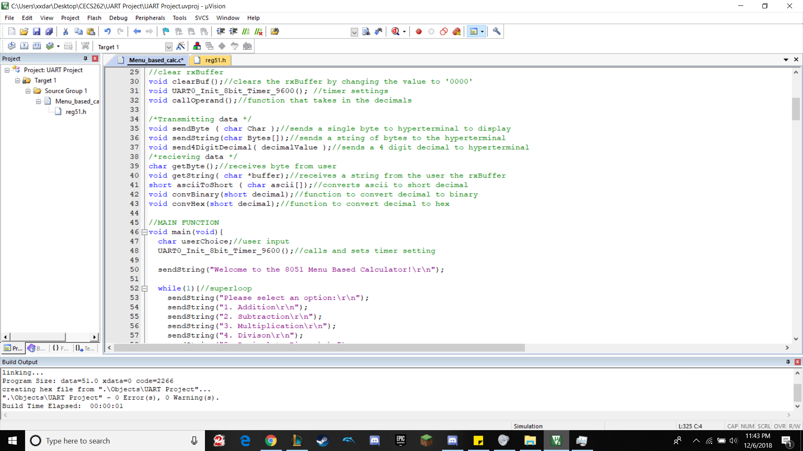

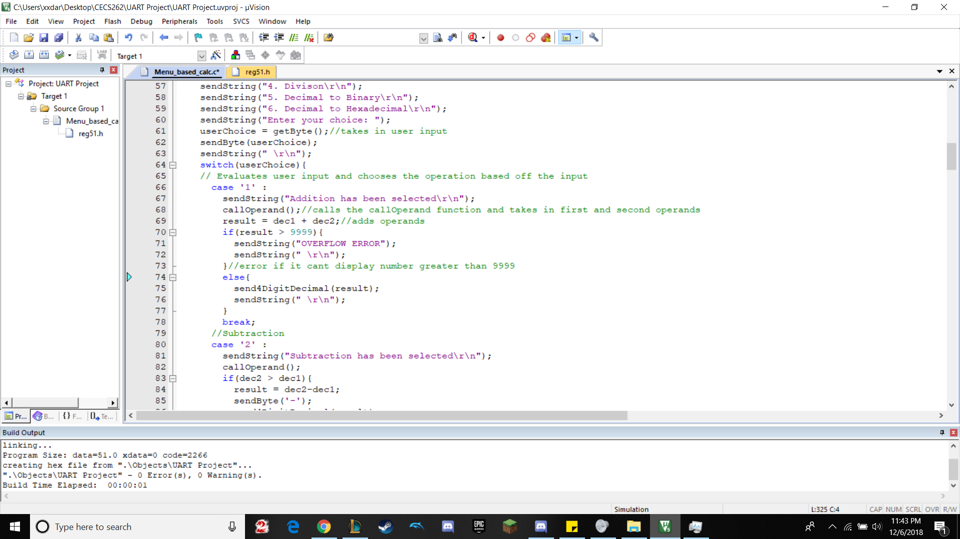

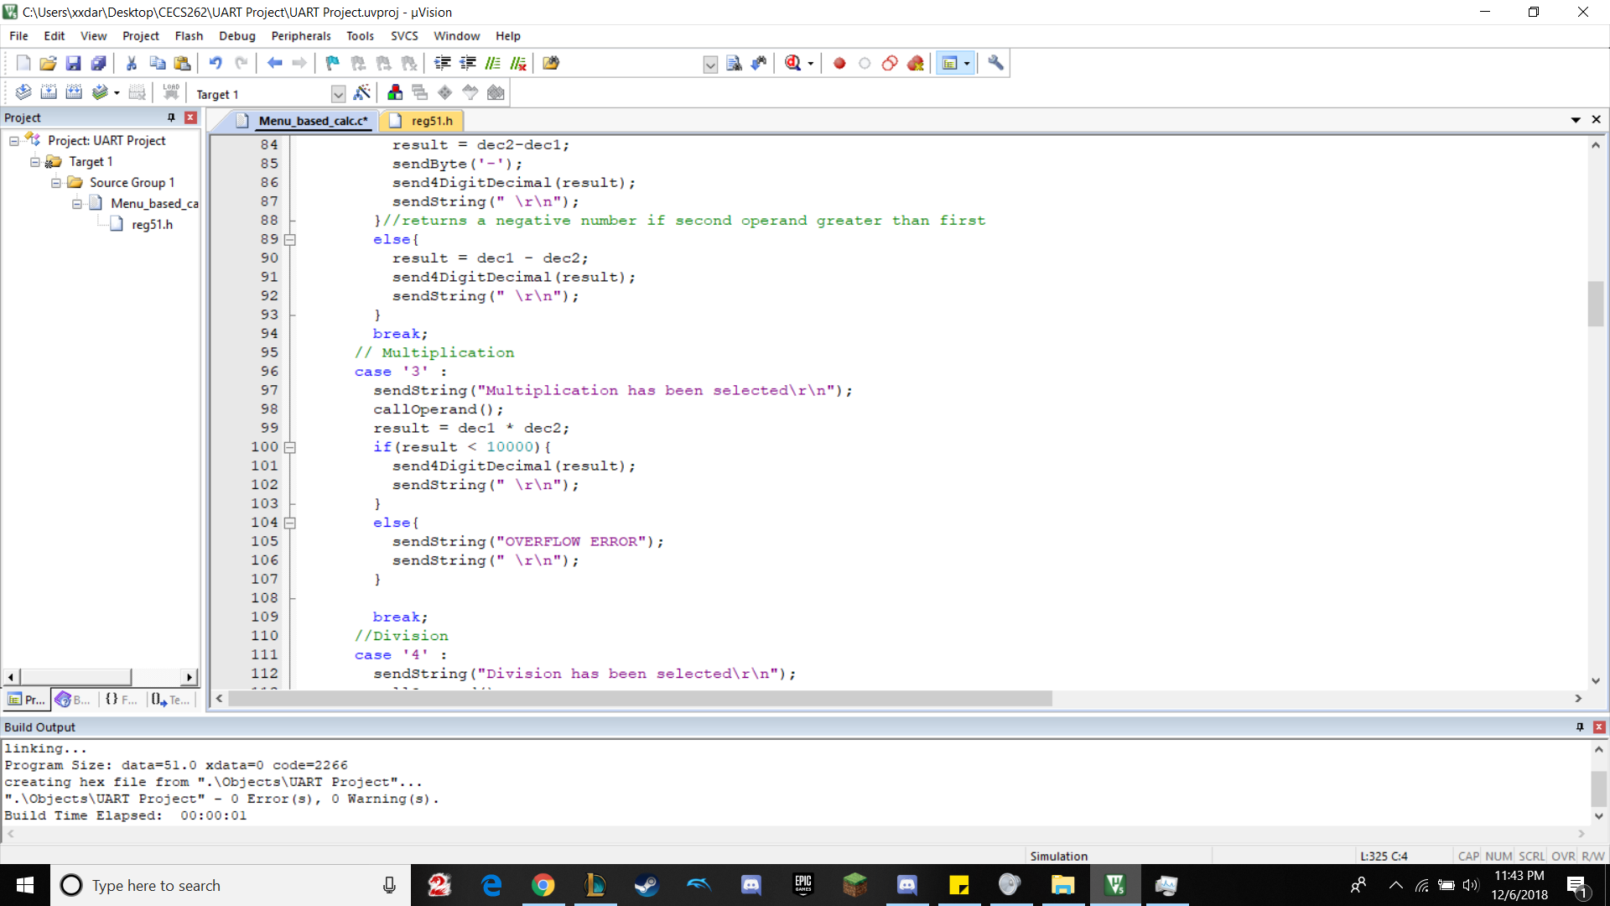

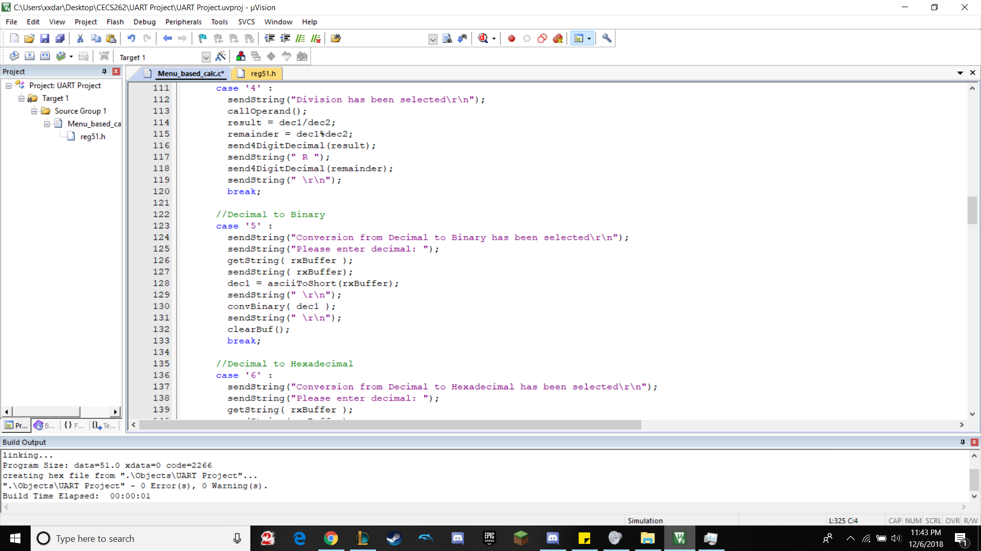

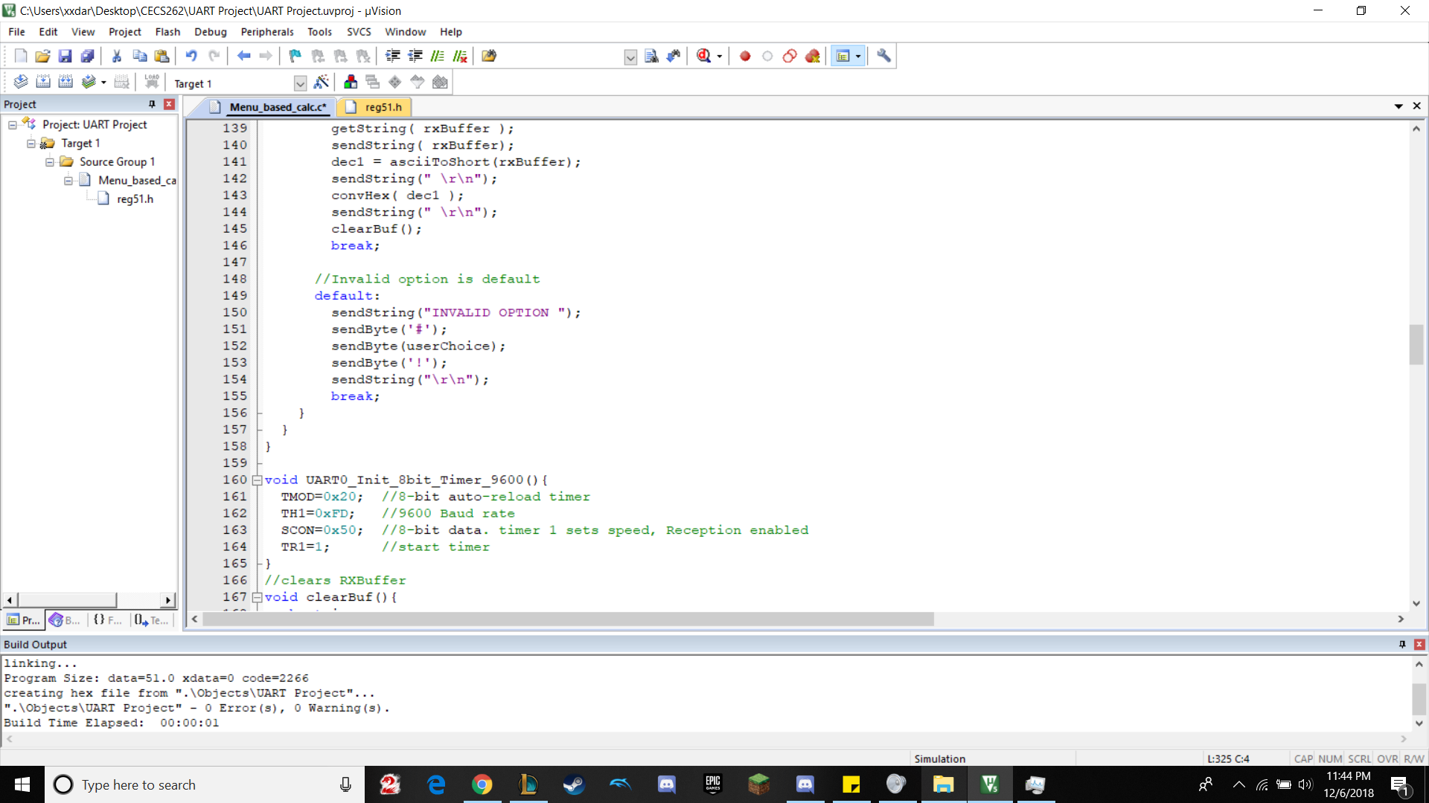

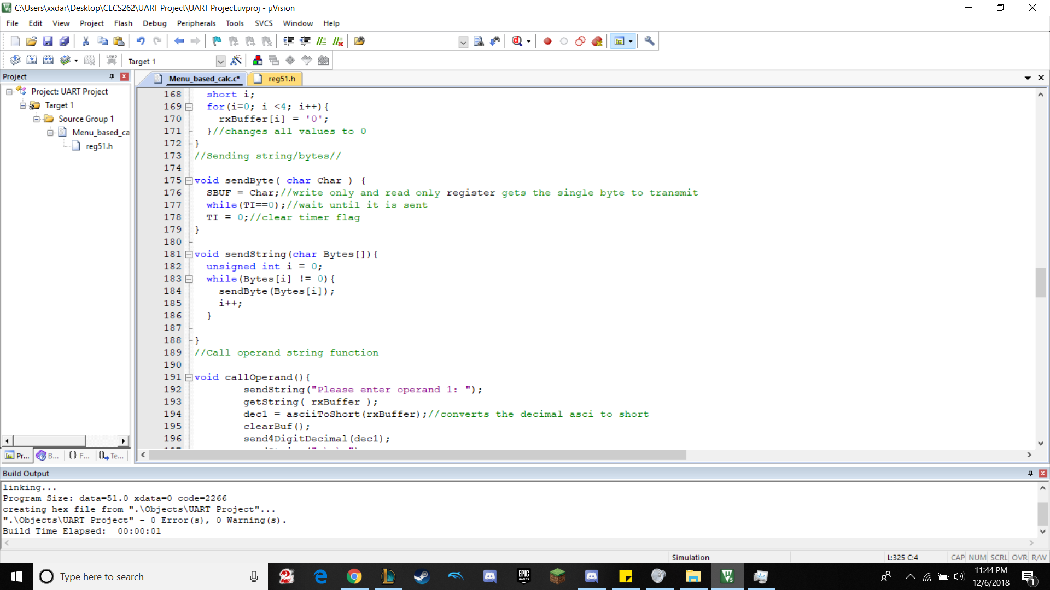

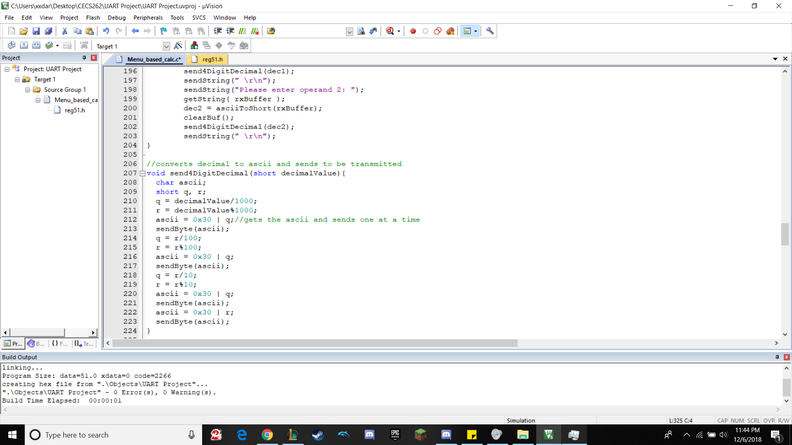

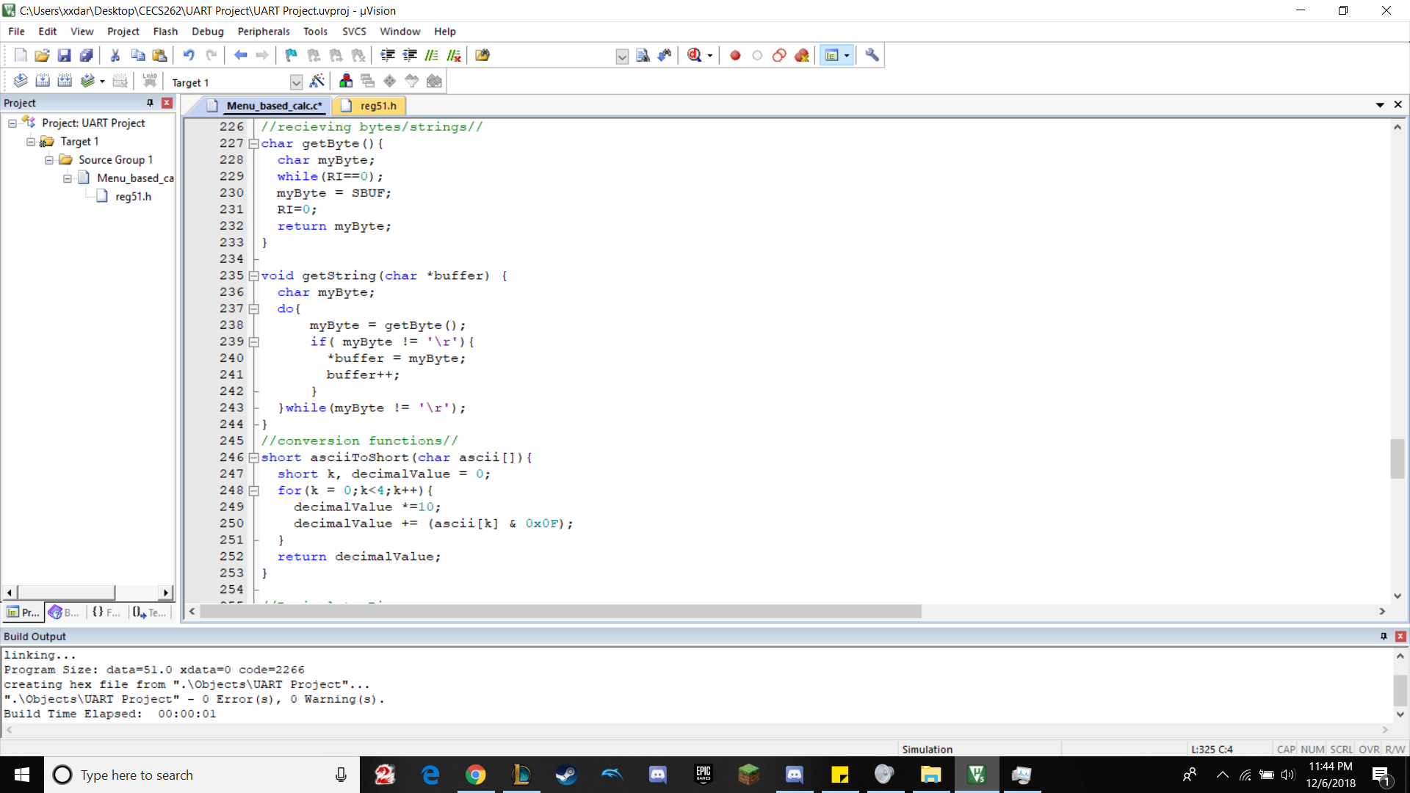

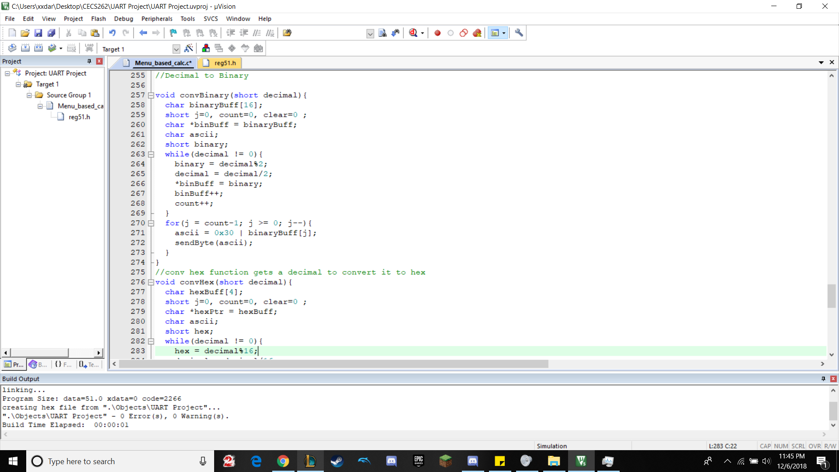

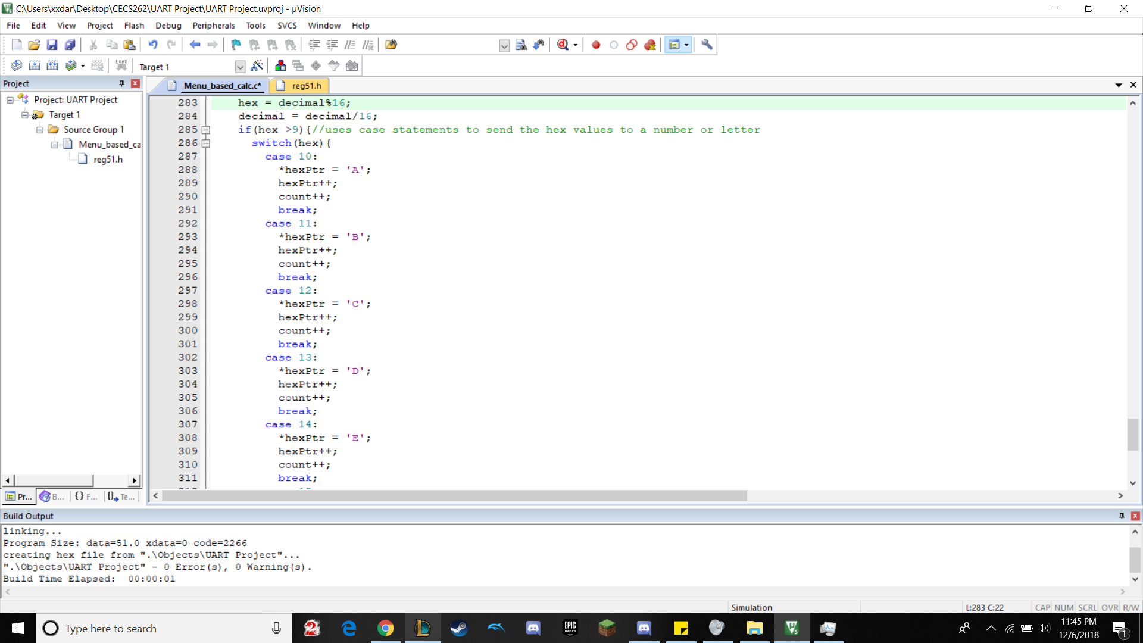

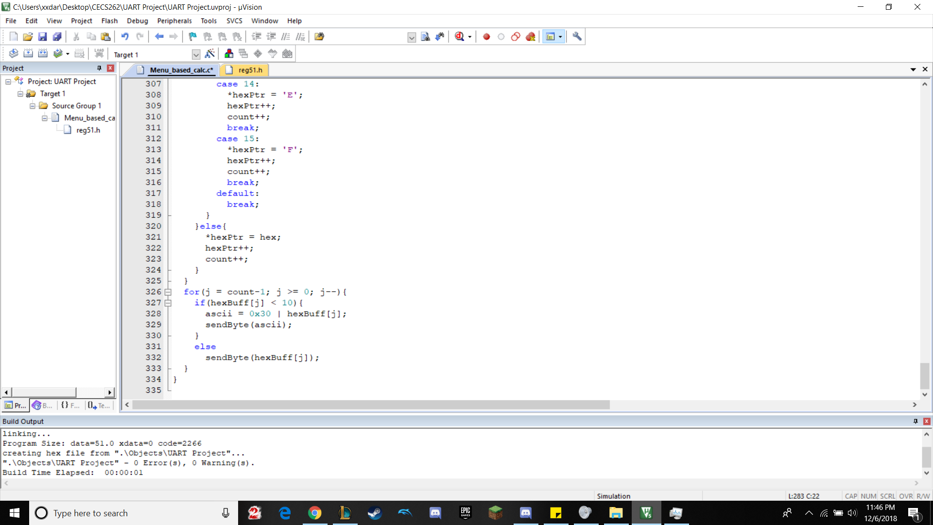

Screenshots of Program Operation

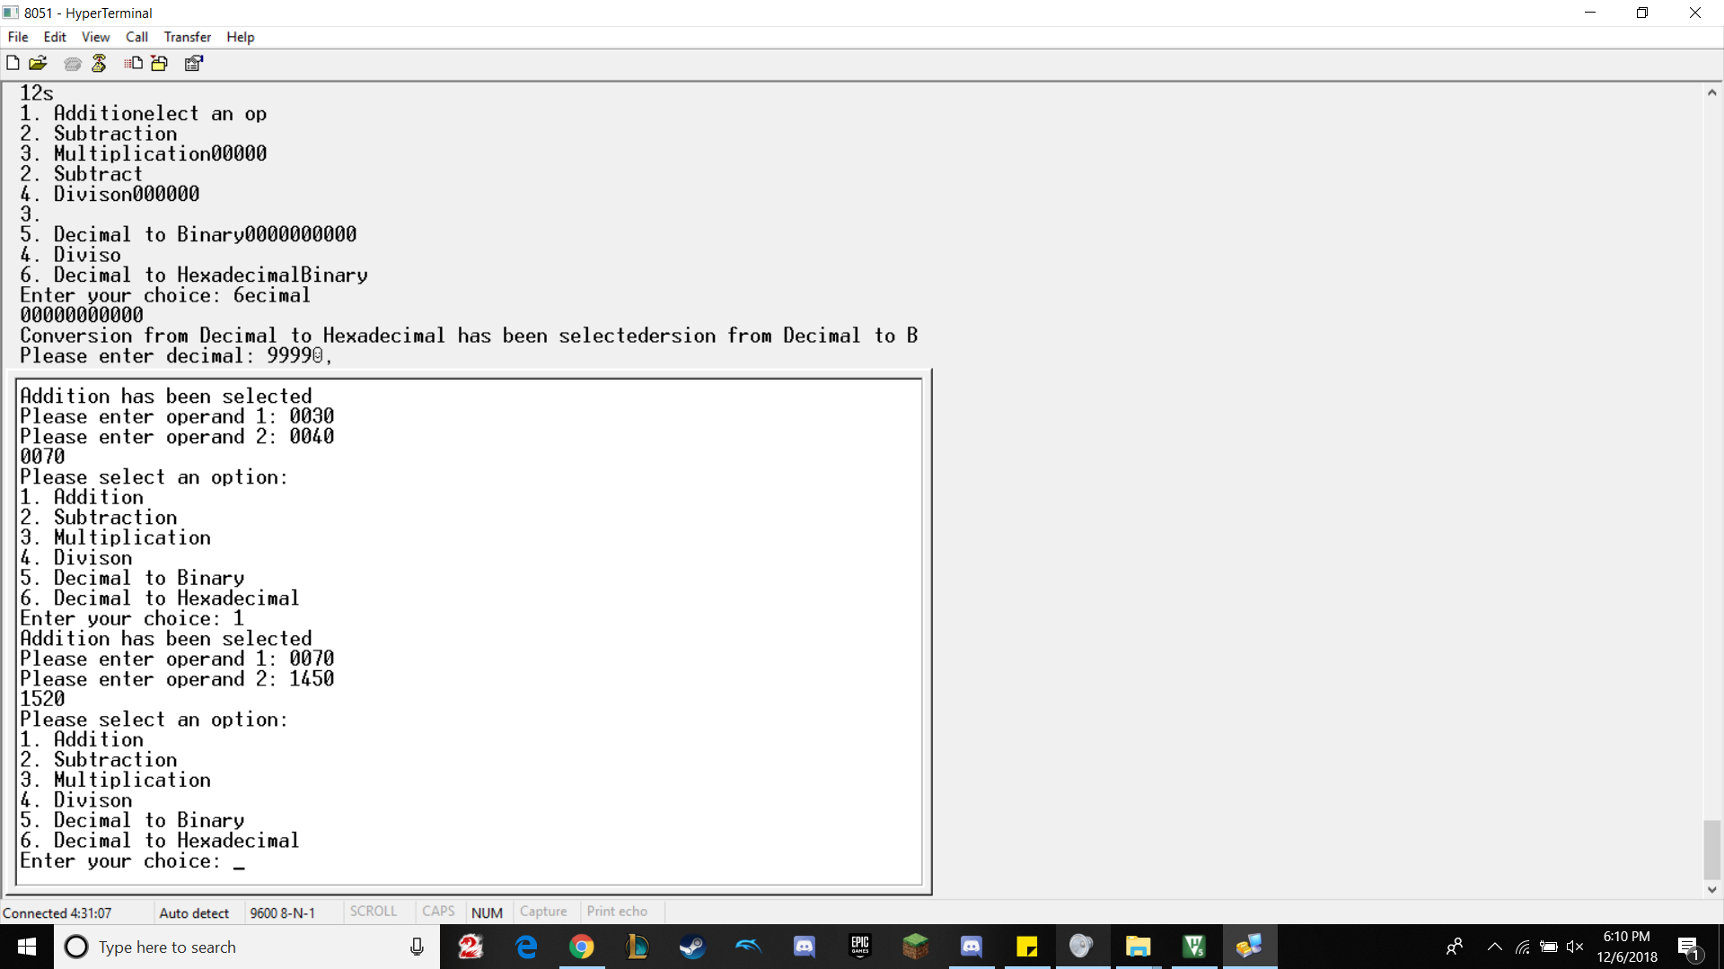

The above picture shows the addition operation.

30 + 40 = 70, 70 + 1450 = 1520

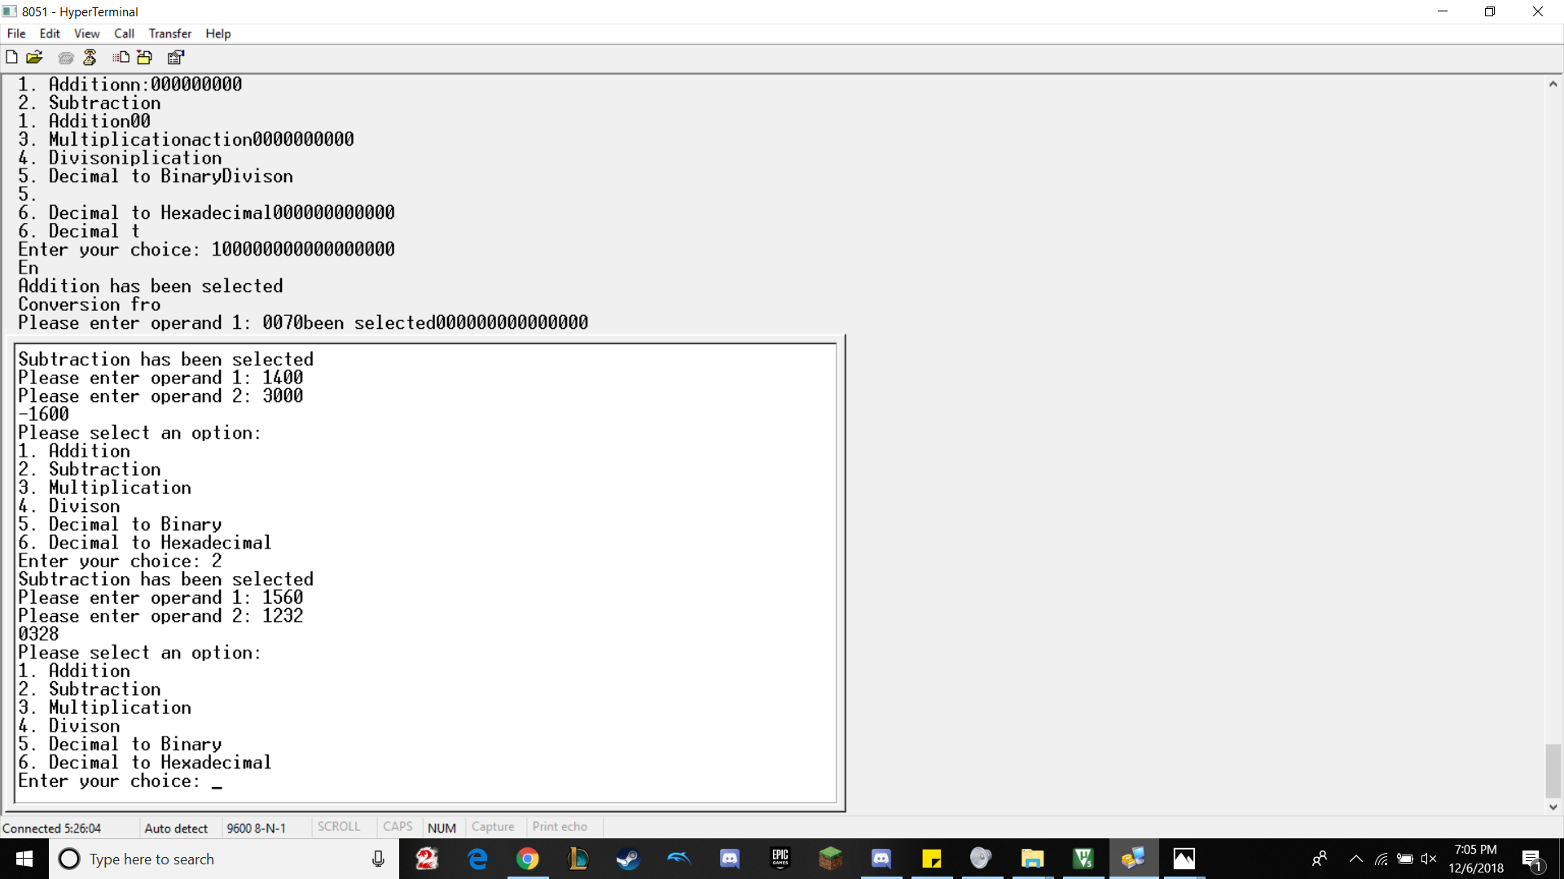

The above picture shows the subtraction operation. Also shows that if you subtract a larger number from a smaller number, you get a negative.

1400-3000 = -1600, 1560 - 1232 = 328

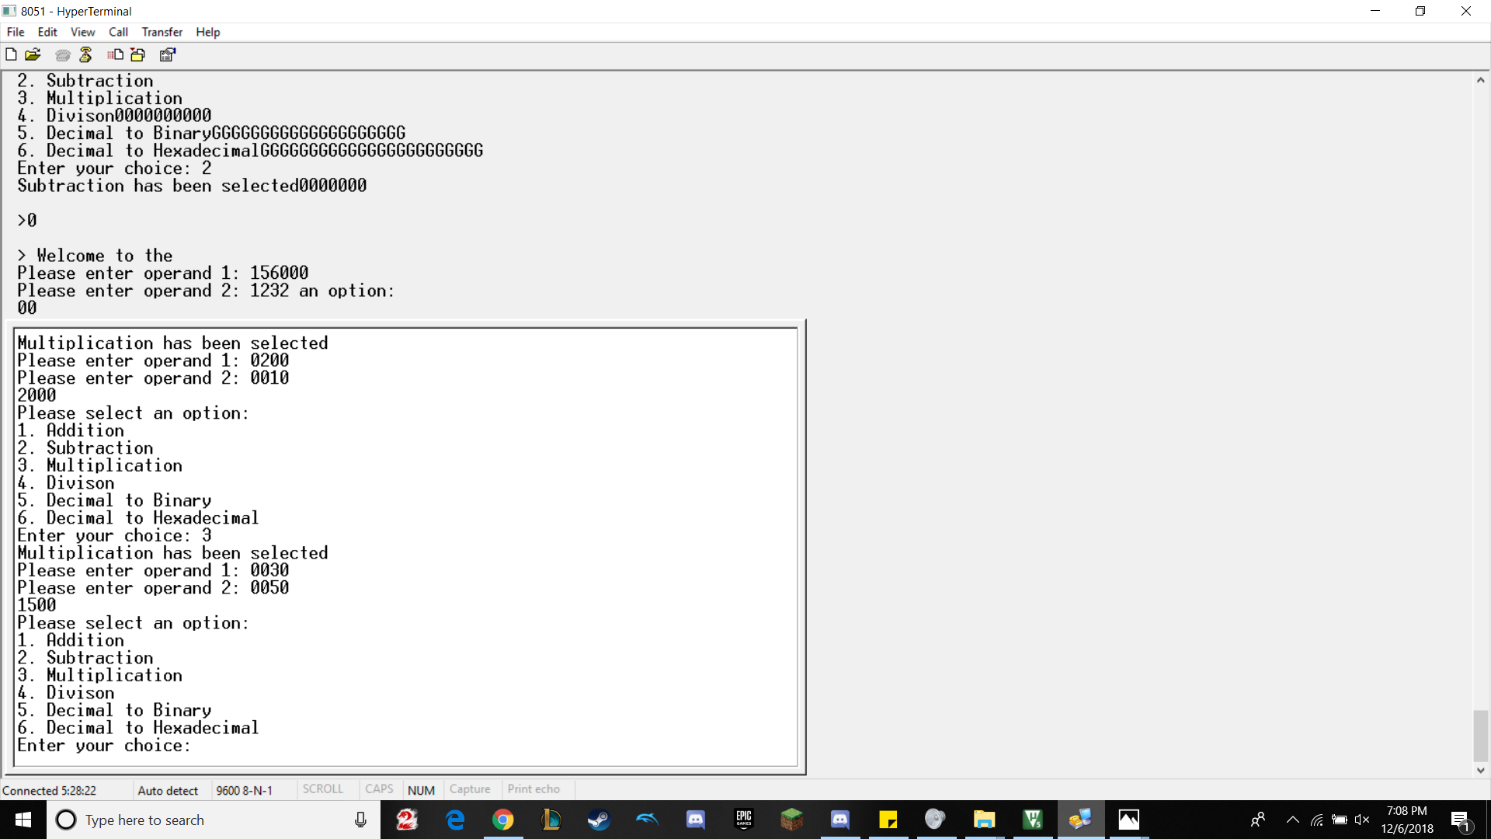

The above picture shows the Multiplication operation

200 * 10 = 2000, 30*50 = 1500

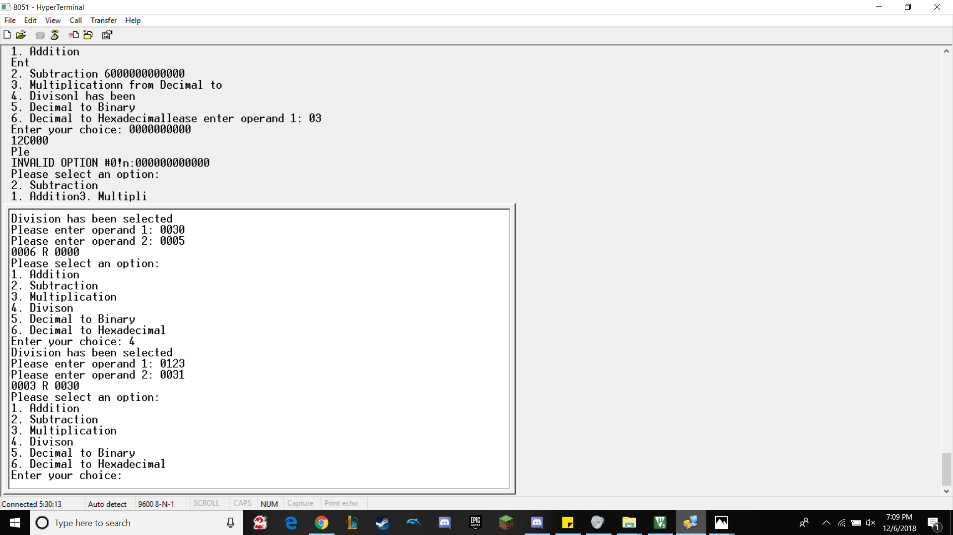

The above picture shows the Division operation

30/5 = 6 R 0, 123/31 = 3 R 30

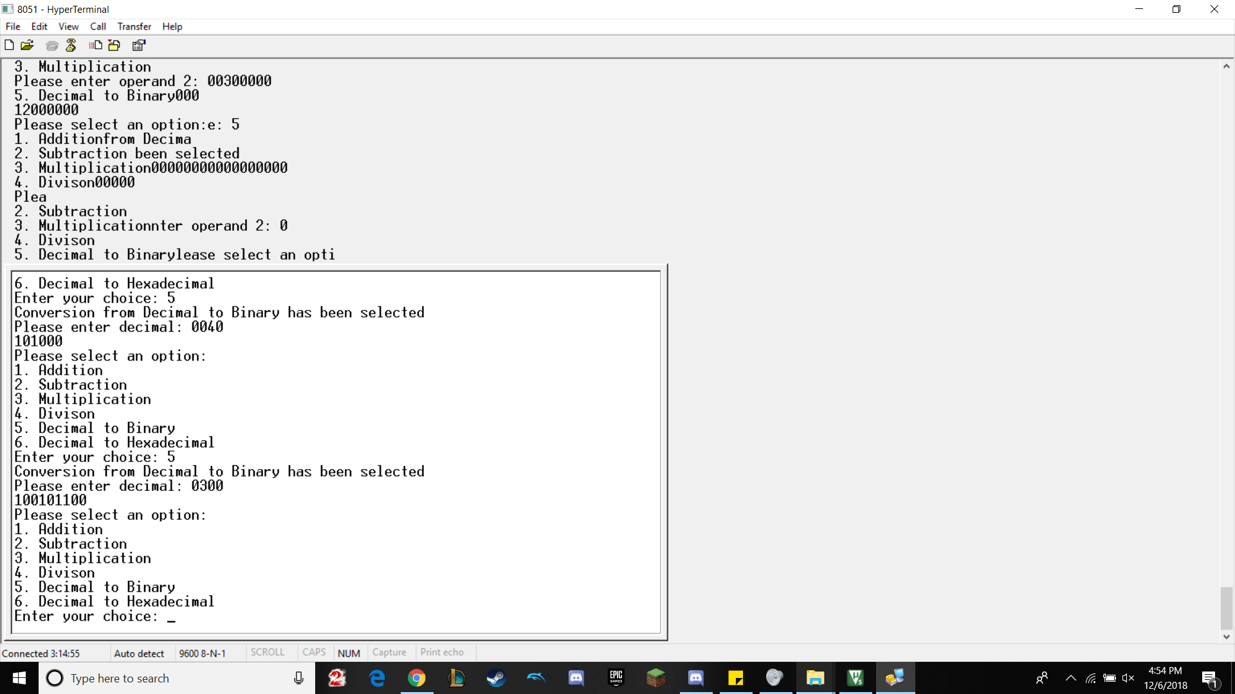

The above pictures shows the operation, Conversion from Decimal to Binary

40 in binary = 101000, 300 in binary = 100101100

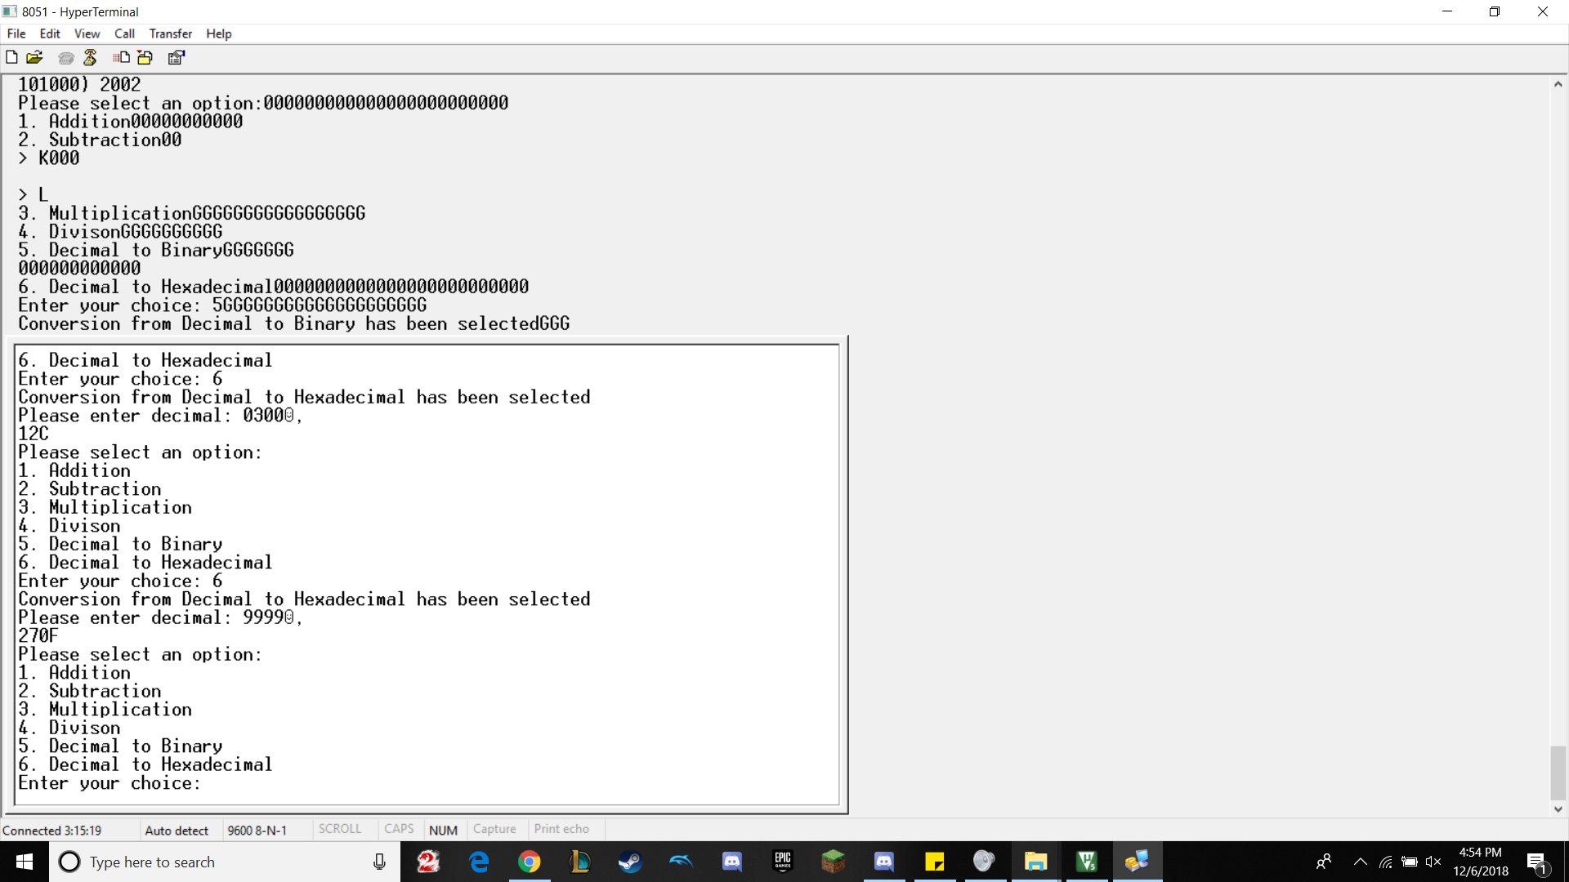

The above pictures shows the operation, Conversion from Decimal to Hexadecimal

300 in hex = 12C, 9999 in hex = 270F

Conclusion

In conclusion, this project helped us learn and understand how to send and receive bits of data between the 8051 board and hyperterminal. Furthermore, we learned how to apply our knowledge of C language and apply it to create a menu in which the user could simulate simple calculator operations. We also added decimal to binary and decimal to hex functions to make our project unique compared to others, which also strengthened our understanding of C language.